Tatton Wildlife Newsletter – Spring

As the natural world awakens, the longer, warmer spring days allow more opportunity to explore our wonderful parkland and all it has to offer. Spring is a season of change, so what better time than now to get out there and enjoy this wonderful season!
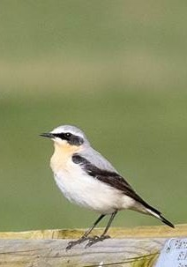
Birds
The great white egret is still resident, moving between the two meres, it is a stunning bird that can’t be missed. A very scarce hawfinch was seen in the gardens in January, there have been more sightings nationally of this large finch during winter, but usually they are very rare. Barn owls were also seen regularly hunting over the parkland, even during daylight hours. Though they are always a pleasure to see, this is a sign that they are struggling for food which consists of small rodents, due to snow cover or high winds.
Spring is a great time to see birds as many are on migration and they are in their bright spring plumage. Summer migrants now arrive, the first being the eagerly awaited sand martin which can be seen hawking insects over Tatton Mere. These are closely followed by a variety of warbler species, and later, swallows and swifts. Look out for wheatears (pictured) that can be seen here during spring on migration.
Butterflies
One of the earliest butterflies on the wing is the brimstone and is always a pleasure to see on a spring day. Small tortoiseshell can be seen in spring too. We will be carrying out our butterfly survey again this year and although numbers were down last year, we hope this year will be an improvement.

Deer
The deer will now moult into their summer coats. The red deer have a deep russet coat and the fallow a more speckled, lighter coat. The fallow deer do have darker (melanistic) and whiter (leucistic) types too.
Hormonal changes within their bodies due to day length, trigger the male deer to cast their antlers at this time of year. They are cast from what is known as the pedicle, the blood that can be seen at this point straight after casting soon dries up and the new antlers will begin to grow immediately. At this point the antlers are soft and growing, and they are now known to be ‘in velvet’

Spring woodlands
As winter turns to spring, the first leaves and flowers of native trees begin to emerge. In March, watch for buds bursting on ash, beech, oak and rowan trees and the first leaves emerging from alder, field maple and silver birch. Spring is also a great time for both wildflowers and tree blossom providing an early nectar source for bees, butterflies and other insects. Before the trees are in full leaf, wildflowers make the most of light reaching the ground – bluebells, wood anemone (pictured) marsh marigold and lesser celandine are some of the species to look out for, with Dog Wood providing excellent viewing. The thinning and coppicing work undertaken in Tatton’s woodlands has enabled wildflowers to flourish by decreasing the canopy cover and opening glades. As the volume and variety of flowers grows, so too does the pollinator population that feeds on them.
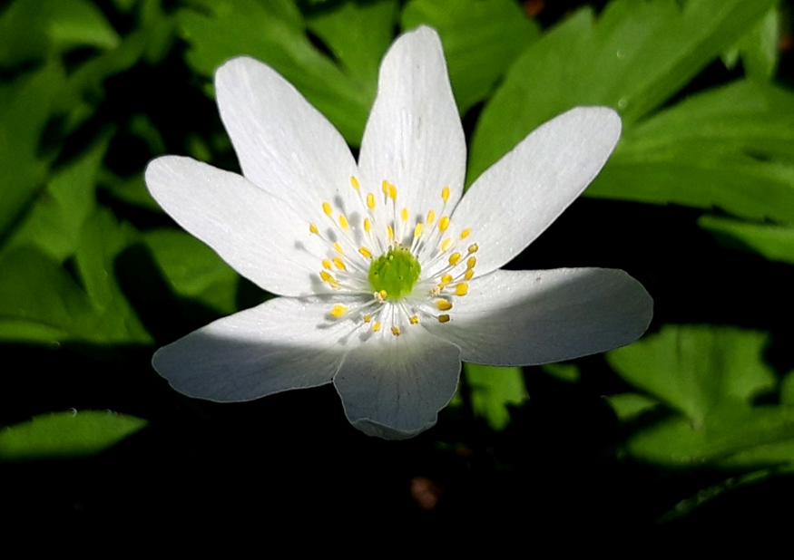
Compiled by Tatton’s Ranger Team

